**Ad Targeting and Personalization - Entertainment Sector**

Pooja Joshi & E.Code [E25007]

# Overview :

This project focuses on building a personalized ad recommendation system for the entertainment sector. The goal is to segment users based on their movie-watching habits and deliver targeted ads that align with their preferences, thus enhancing engagement and relevance.

# Objective:

The main objective is to improve the precision of ad delivery by predicting audience segments using user data and recommending appropriate ads for each segment.

# Assigned Task(s) :

· **Data Preprocessing**: Clean and transform data for machine learning.

· **Model Training**: Train a RandomForest model for audience segmentation.

· **Ad Recommendation**: Recommend ads based on the predicted segment.

· **Visualization**: Display feature importance and ad recommendation distribution.

# Task Details

· **Task 1**: **Data preprocessing using pipelines for numeric and categorical features.**

* **Status**: Completed
* **Details**: The data was successfully preprocessed using both standardization and one-hot encoding.

· **Task 2**: **Train and evaluate the RandomForest classifier.**

* **Status**: Completed
* **Details**: The model achieved a reasonable accuracy score and provided useful feature importance metrics.

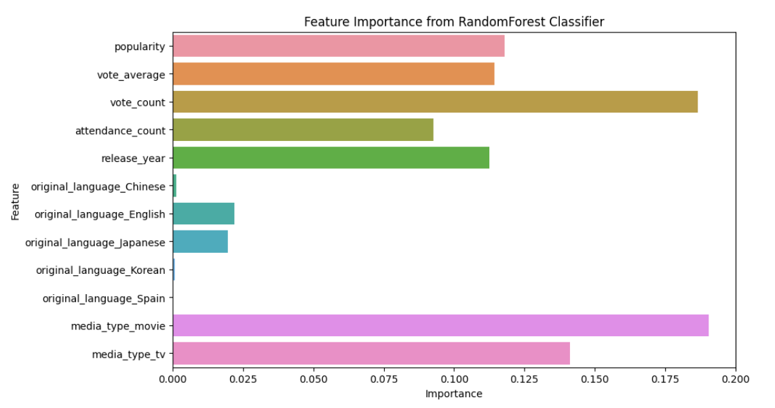

· **Task 3**: **Ad recommendation system**.

* **Status**: Completed
* **Details**: Ads were successfully recommended based on predicted audience segments.

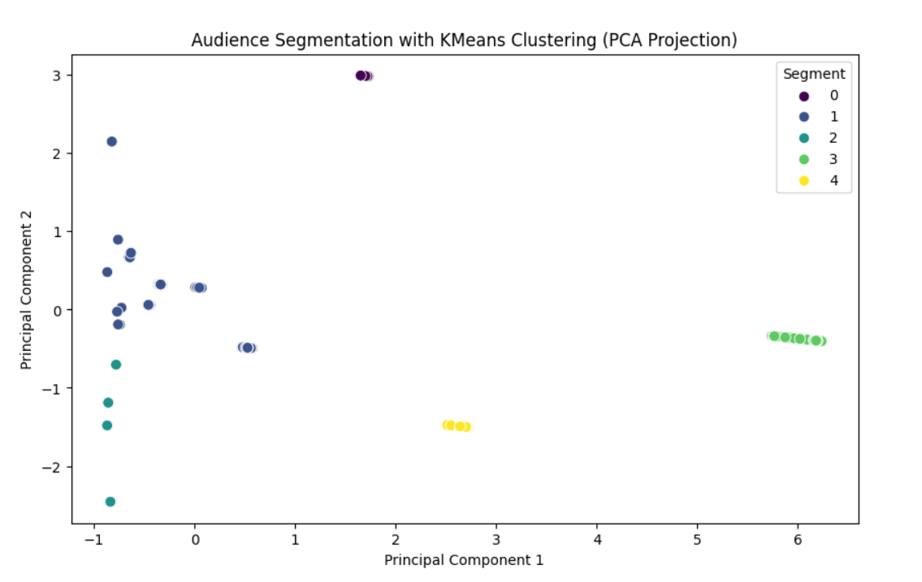

· **Task 4**: **Visualization of results.**

* **Status**: Completed
* **Details**: Feature importance and ad recommendation distribution were visualized effectively.

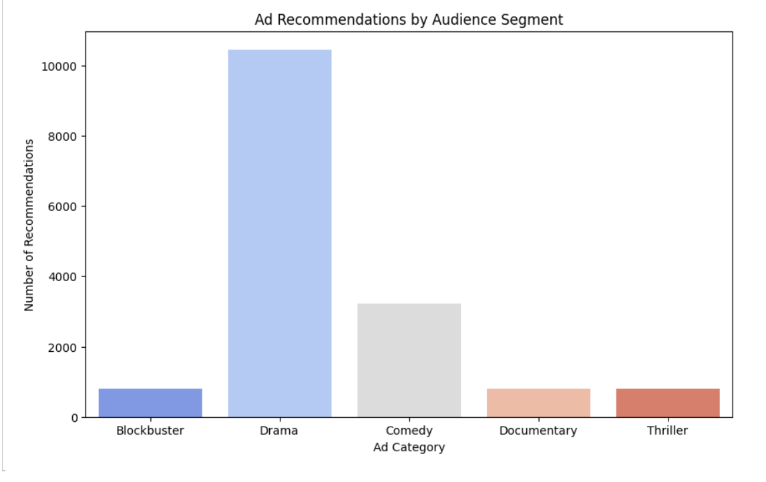

# Progress :

· **Accomplishments**: The model successfully segmented the audience and provided relevant ad recommendations. The ad recommendation system is functional and integrates well with audience data.

· **Metrics**: The model achieved good accuracy, and the feature importance analysis indicated that movie ratings and gross income were significant factors in segmentation.

# Challenges and Solutions :

· **Challenges Faced**: Handling the categorical features and ensuring the data was clean for model training posed some difficulties.

· **Solutions Implemented**: A robust preprocessing pipeline was created, which handled these issues effectively.

·

# Next Steps :

· **Upcoming Tasks**: Experiment with different models or hyperparameter tuning to improve performance.

· **Goals**: Improve model accuracy and test the system with new data sources.

# Conclusion :

# Summary: The project has made significant progress in developing a personalized ad targeting system for the entertainment sector. Ads are recommended based on predicted user segments, increasing the relevance of the content shown to users.

# **Acknowledgments**: Thank the audience for their time and attention.

# Instructions:

1. Use Google Docs. Single Column
2. TNR stands for Times New Roman: B - Bold
3. Use images as required with proper references
4. Use charts, tables as per your requirement.
5. Number of Pages: 2 to 8 for each task report.